1. Search “Download SQL Server” on Google

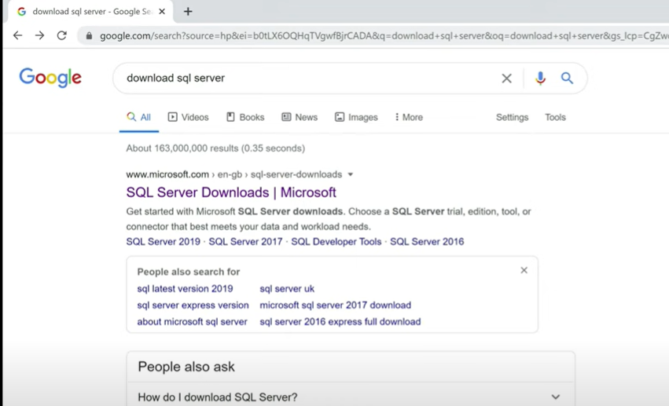

1. Click on <https://www.microsoft.com/en-in/sql-server/sql-server-downloads>, scroll down and click on download now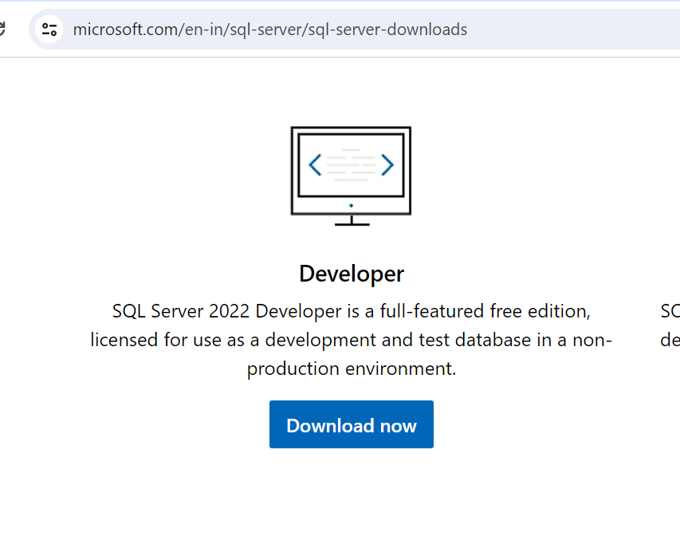
2. Double click on the downloaded software

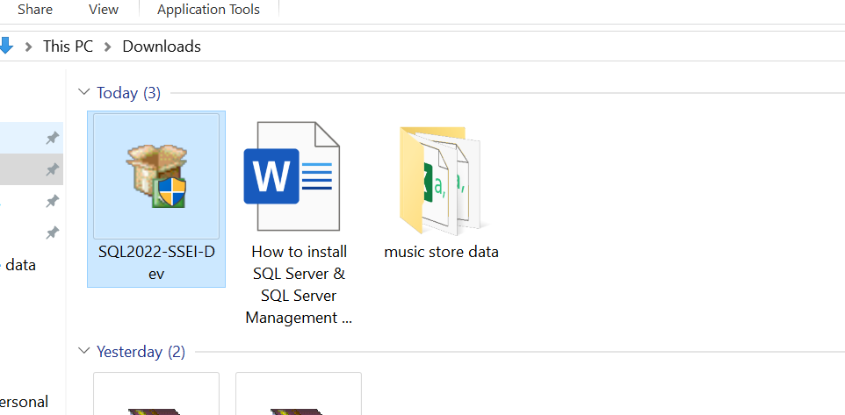

1. Click On “Basic”

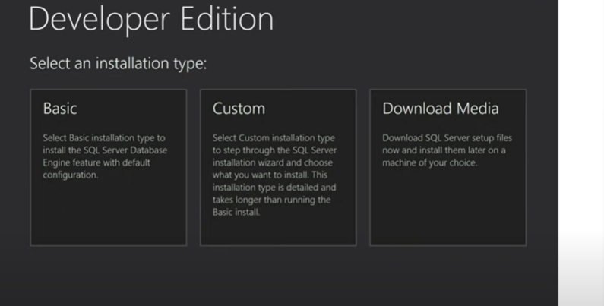

1. Click On Accept

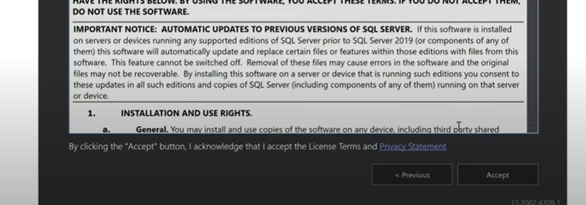

1. Click On install

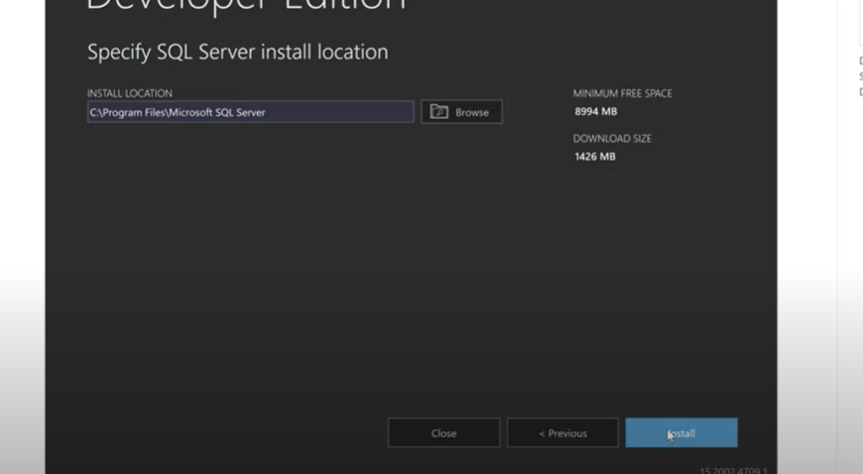

1. Click SSMS

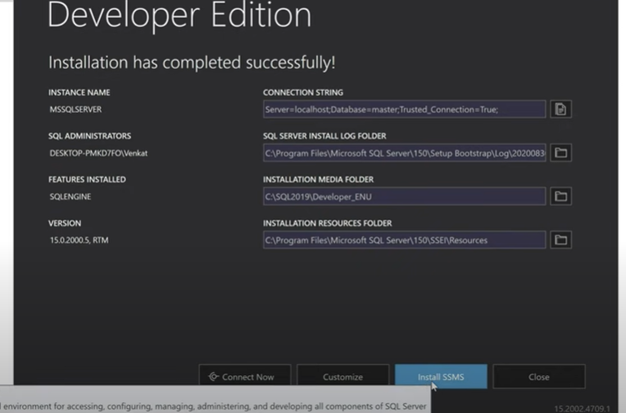

1. Download SQL Server Management Studio (SSMS)

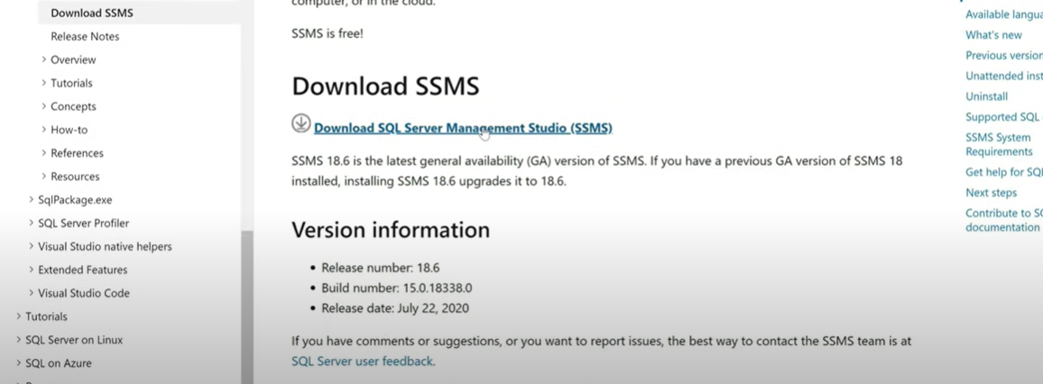

1. Click on SSMS-Setup icon

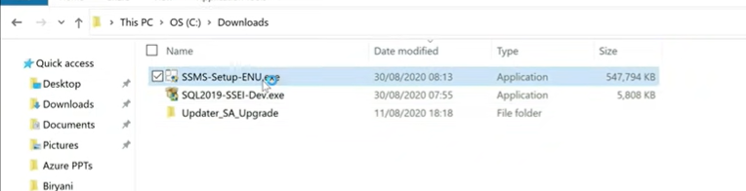

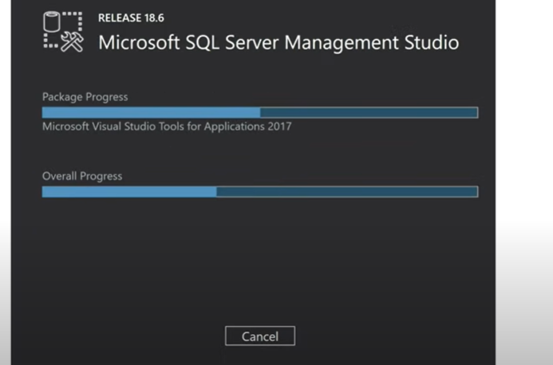

1. Press Window, select Microsoft SQL Server Management Studio 18

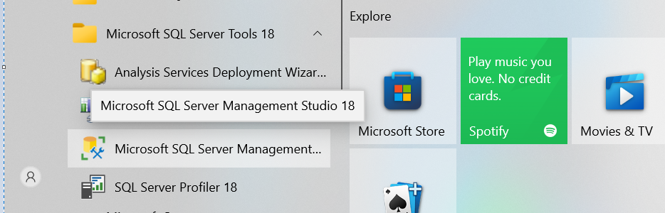

1. Select Window Authentication

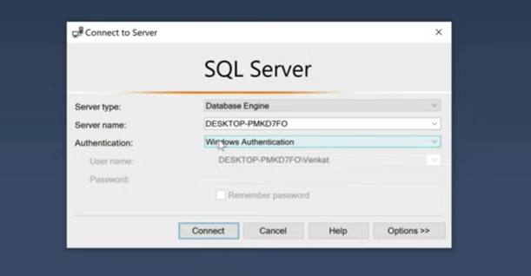

1. Click on New Query to launch editor

